**Melisk Yeldrai** 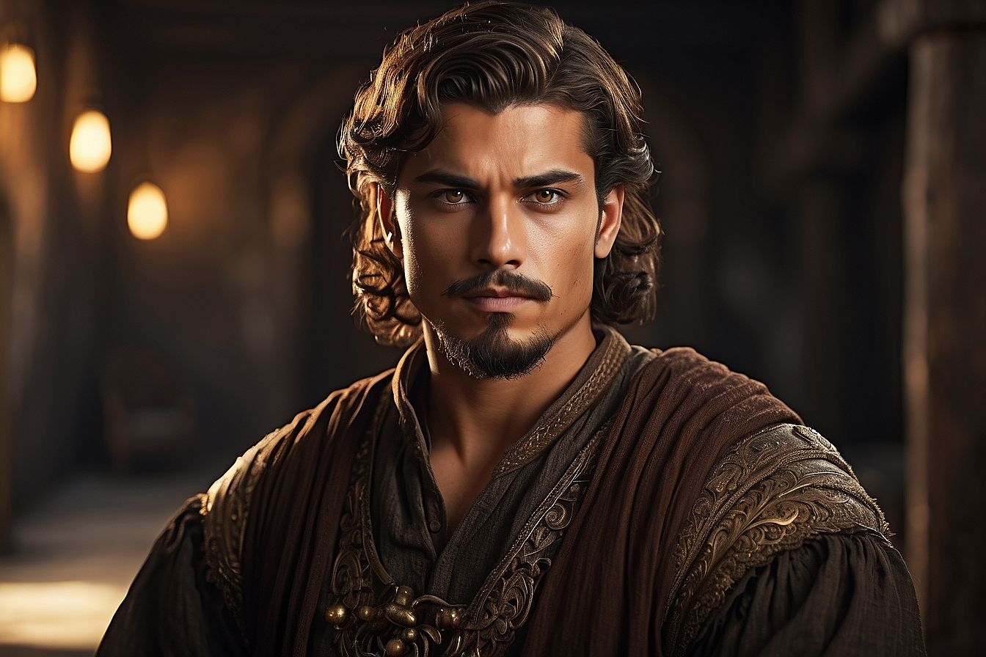 Bathhouse owner

**Marmeron Ulanthas**

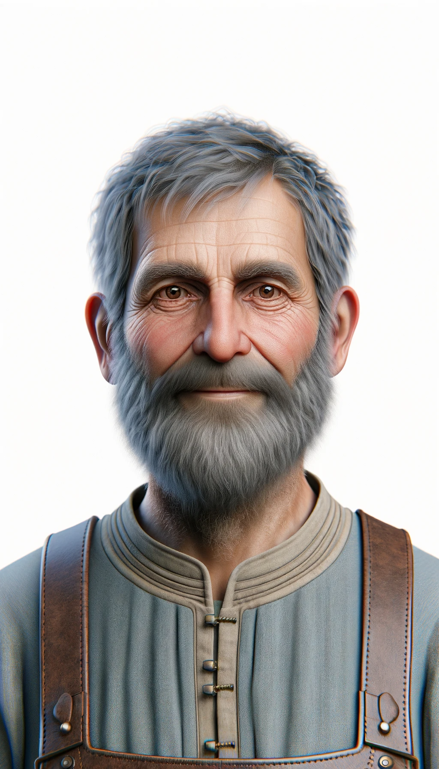

Bartender

**Miranei Jethrik**

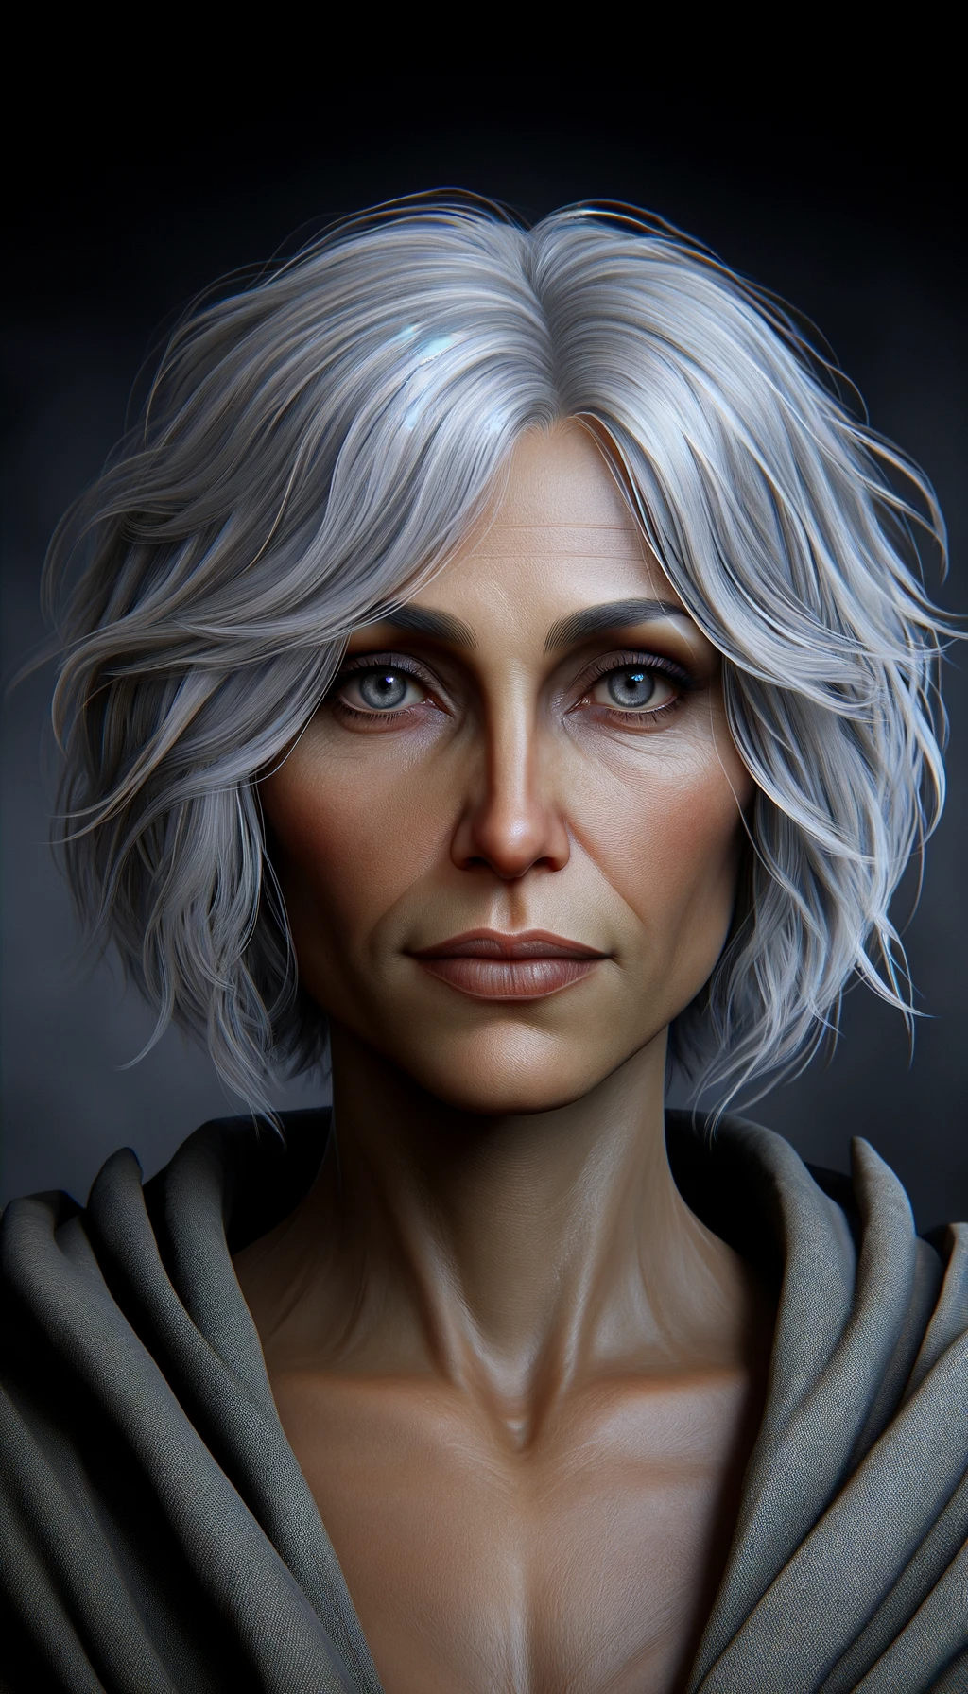

Advisor to the Lord

**Larnste Vibur**

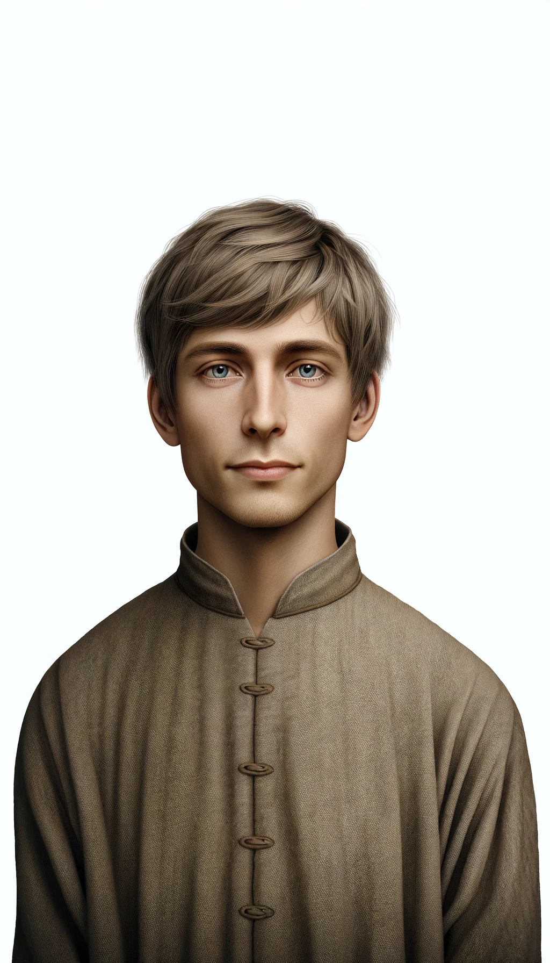

Scribe